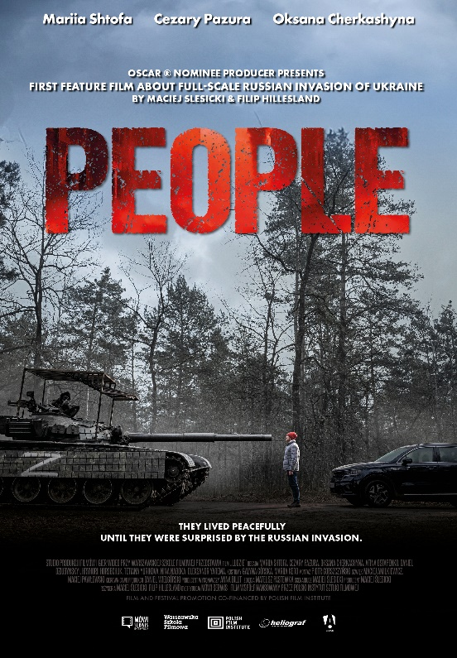**Global Screenings of “People” Film to Commemorate Third Anniversary of Ukraine’s Defense Against Russian Invasion**

The film “People,” directed by Maciej Ślesicki (also two times Oscar nominee as a producer of short films) and Filip Hillesland, is set to be showcased in over 50 cities across more than 40 countries worldwide as part of the event "Third Anniversary: Unity in the Face of Threat," commemorating the third anniversary of Ukraine's defense against the Russian invasion. The worldwide distributor is company Kinostar from Germany. The Polish distributor is Mówi Serwis. Producent – Warsaw Film School. Anniversaries screenings are supported by Polish Film Institute.

This event aims to remind the world and the international audience about the ongoing war in Ukraine and to express solidarity with Ukrainians who continue to endure the brutality of Russian aggression. Screenings will take place from February 18 through the end of March in cities including Algiers, Amman, Austin, Baku, Bangkok, Berlin, Bogota, Brussels, Budapest, Buenos Aires, Canberra, Chicago, Dakar, Dallas, Denver, Dublin, Geneva, The Hague, Havana, Hong Kong, Kyiv, Lisbon, London, Mexico City, Miami, Moscow, New York, Washington, Wellington, Santiago, Seattle, Sydney, Tbilisi, Tokyo, Vancouver, and Vatican City.

On the 16th of February, 2025 film is presented to film industries at the EFM Market at Berlinale Film Festival.

Beginning February 21, the film will have screenings across Germany in cinema chains including:

CINESTAR, with locations in Augsburg, Berlin Cubix, Bremen, Chemnitz, Dortmund, Dusseldorf, Erfurt, Frankfurt/Main Metropolis; Karlsruhe, Leipzig, Lubeck, Mainz, Oberhausen Village Cinema, Rostock, Saarbrücken, Villingen/Schwenningen

KINOPOLIS venues in towns Aschaffenb AB, Bad Homburg BHG, Bonn Bad-G BN, Citydome Darmstadt DA CD, Freiberg/Sachsen FR, Gießen GI KP, Hanau HU, Landshut LH, Munchin Matha M M, Universum-City Karlsruhe KA.

KINOCENTER in Borken

Additionally one Cinema in Belgium - Kinopolis in Brussel

The film will have screenings across England in cinema chains including:

CINEWORLD in the cities: Basildon, Bradford, Hounslow, Leeds, Milton Keynes, O2, Rushden Lakes, Wandsworth, Showcase, Bluewater, Bristol, Peterborough, Reading, Southampton, Leeds;

VUE in the cities: Blackburn Cheshire Oaks, Doncaster, Leeds Light, Longwell Green, Manchester Printworks, Northampton, Plymouth, Portsmouth, Reading, Romford, Shepherds Bush, Star City, Westfield Stratford, York

ODEON will show it from February 28th.

Organized partially in collaboration with Polish and Ukrainian diplomatic institutions, the film will also kick off the European Film Festival in Hong Kong. Screenings in Washington, D.C. are slated for March and April, with Congressional representatives in attendance, and the film will be showcased to members of the European Parliament in April. The Ministry of Foreign Affairs has taken patronage over the screenings.

“People” will make its debut in Polish cinemas on February 21. International media are covering the film's global showings, including a feature in THE HOLLYWOOD REPORTER and THE GUARDIAN.

<https://www.hollywoodreporter.com/movies/movie-news/people-film-ukraine-war-global-screenings-solidarity-event-1236132160/>

<https://www.theguardian.com/film/2025/feb/17/people-ludzie-review-multi-thread-epic-offers-raw-tales-from-the-russia-ukraine-war?trk=feed_main-feed-card_feed-article-content>

“People” presents a poignant war drama that follows the lives of five women forced to make desperate choices in a time of war. Inspired by true events from the first days of Russia's attack on Ukraine, the film portrays the absurdity and brutality of conflict from the perspective of civilians. Director Maciej Ślesicki highlighted that the film was born from a sense of injustice and disagreement over the atrocities of war.

In a world increasingly indifferent to the topic of war, the need to remind societies of Ukraine’s plight is urgent, especially in light of pervasive disinformation campaigns aimed at reshaping narratives surrounding the conflict. The filmmakers aim to enhance awareness of the socio-political situation, reach an international audience, including Russians, and strengthen the faith of Ukrainians in their defense of their homeland. They hope to showcase Poland's significant role in contemporary Europe and the profound commitment of its citizens to aid others at personal risk.

The film, while potentially perceived as shocking and violent, is intended to provoke public opinion, strengthen unity in the face of Putin’s invasion, and rekindle empathy for Ukrainian migrants.

“People” is a heartfelt narrative about sacrifice, courage, and the resilience of the human spirit. The film is directed by Maciej Ślesicki, who also wrote the screenplay, alongside Filip Hillesland. Cinematography is by Mateusz Pastewka. Students from the Warsaw Film School contributed to the production, which features performances by Mariia Shtofa, Cezary Pazura, and Oksana Cherkashyna. The project was produced by the Warsaw Film School with co-financing from the Polish Film Institute, and its distribution in Poland is handled by Dystrybucja Mówi Serwis.

The filmmakers express, "With this story, we pay tribute to the forgotten victims of the war in Ukraine, individuals who have been tragically affected in their own homes. We also emphasize our duty to assist all war victims and the necessity of ongoing support for the Ukrainian community."

**PEOPLE (original Polish title: LUDZIE)**

Directors: **Maciej Ślesicki & Filip Hillesland**; genre: **war drama**, prod. year: **2024**, country: **Polish**

Cast: **Mariia Shtofa** (Ukrainian actress, known form the film Rhinoceros and several TV series); **Cezary Pazura** (Polish actor, producer, comedian, known from the films Fuks 2, Killer, Netflix series Into the Forest, HBO series Blinded by the Lights); **Oksana Cherkashyna** (Ukrainian actress known for the film Klondike and the series Absolute debutants); **Afina Ostapenko; Tetyana Yurikova** (Ukrainian actor from the films: Bucha, Registrar, Valentyna, series: Provincial, Lady): **Nina Naboka** (Ukrainian actress known for Pryputni, The Big Fight); **Oleksandr Yarema** (Ukrainian actor known from The Battle of Sevastopol, Pamfir, Numbers).

run time: 117 min

Producer: WARSAW FILM SCHOOL, film co-financed by the Polish Film Institute

language: Ukrainian with Polish, available subtitles: English, German, Spanish, Dutch, Polish,

**FILM SYNOPSIS**

When a full-scale war erupts in Ukraine, five women—each from different generations and walks of life—embark on a desperate fight for survival, both for themselves and their loved ones. Their intertwined stories form a compelling narrative about love, sacrifice, and the indomitable human spirit.

The film follows: ● A blind girl who becomes the caretaker of a group of orphans. ● A female doctor who faces a profound moral dilemma while treating a wounded Russian soldier. ● A teenage girl determined to save her younger sister at all costs. ● An elderly woman who refuses to abandon her home. ● A mother who ventures to the front lines in search of her son.

Through the eyes of these women, *PEOPLE* offers a harrowing yet deeply moving portrayal of war, its horrors, and the relentless will to survive.

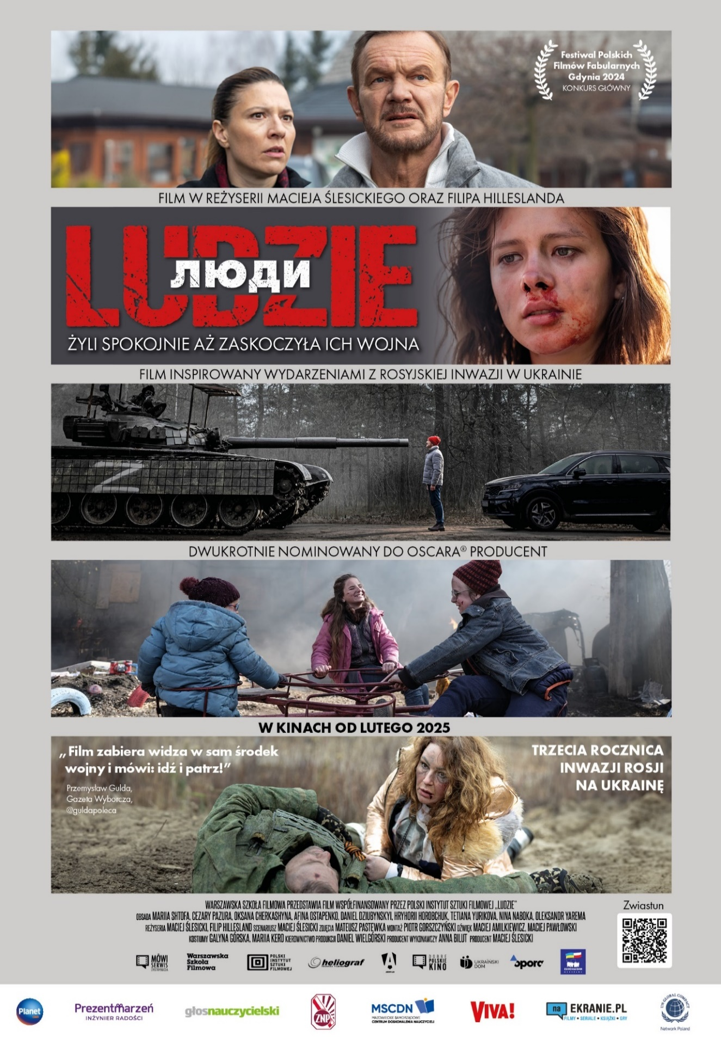

For licensing inquiries, please contact: **Marta Sochacka** – Director of Marketing and Booking  
📧 **msochacka@mowiserwis.pl** | 📞 +48 601 165 207 (Poland)

For screening links and event coordination, please contact: **Łukasz Będkowski**  
📧 **lbedkowski@mowiserwis.pl** | 📞 +48 508 079 594 (Poland)